**33.AWS-Config-CloudTrail-ServiceCatalog**

**Config**

if any company wants to know the changes in particular area there, they use AWS config

Your server is working in t2 micro and you wanted it to change m2 large. Or want to change security groups or you want to change something. In this type of scenarios, you need to raise a change request. All this you want to monitor then you use this config.

Here I will enable monitor for EC2 instance

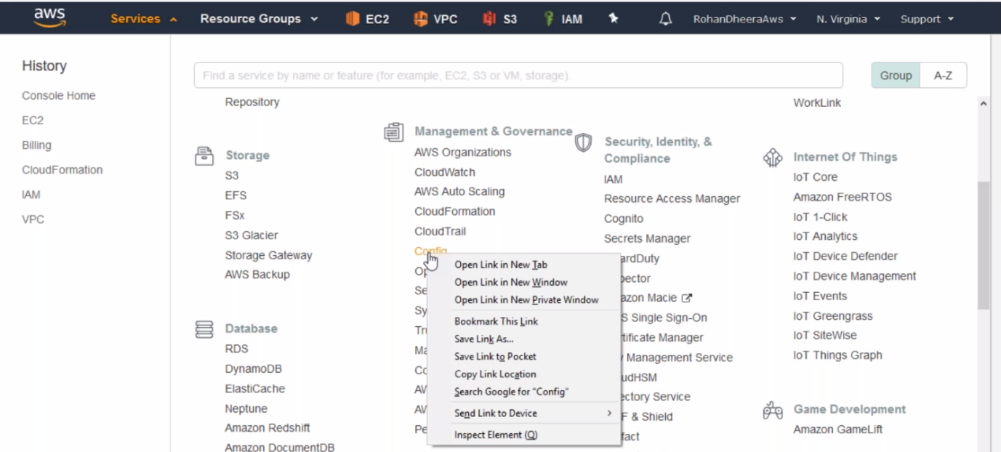

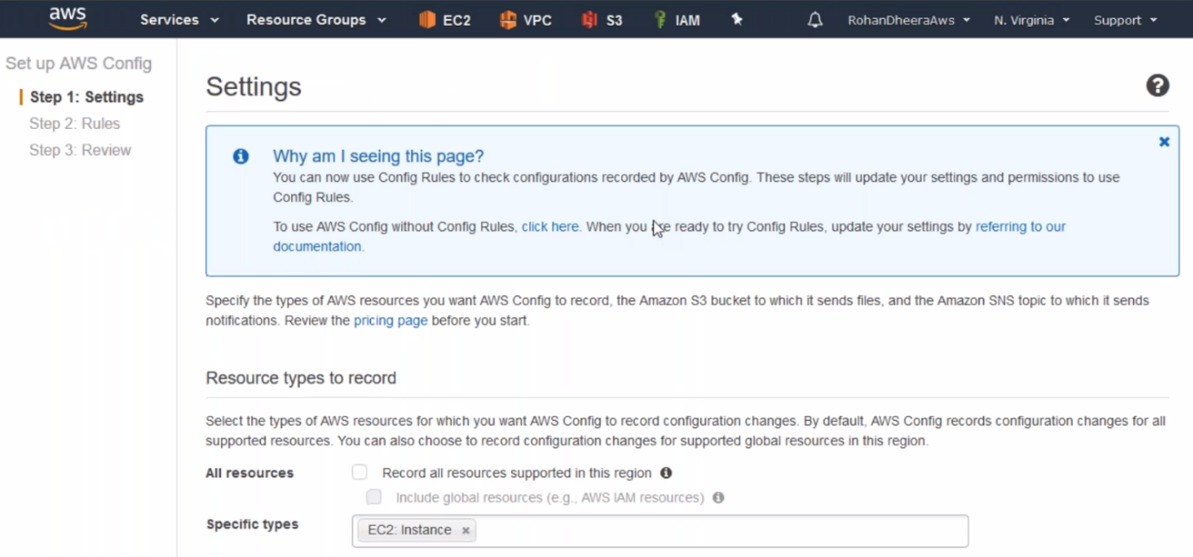--- uncheck all resources because it will record every change that you created.

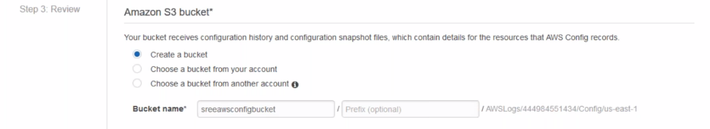

--- we can save the logs in s3 bucket.

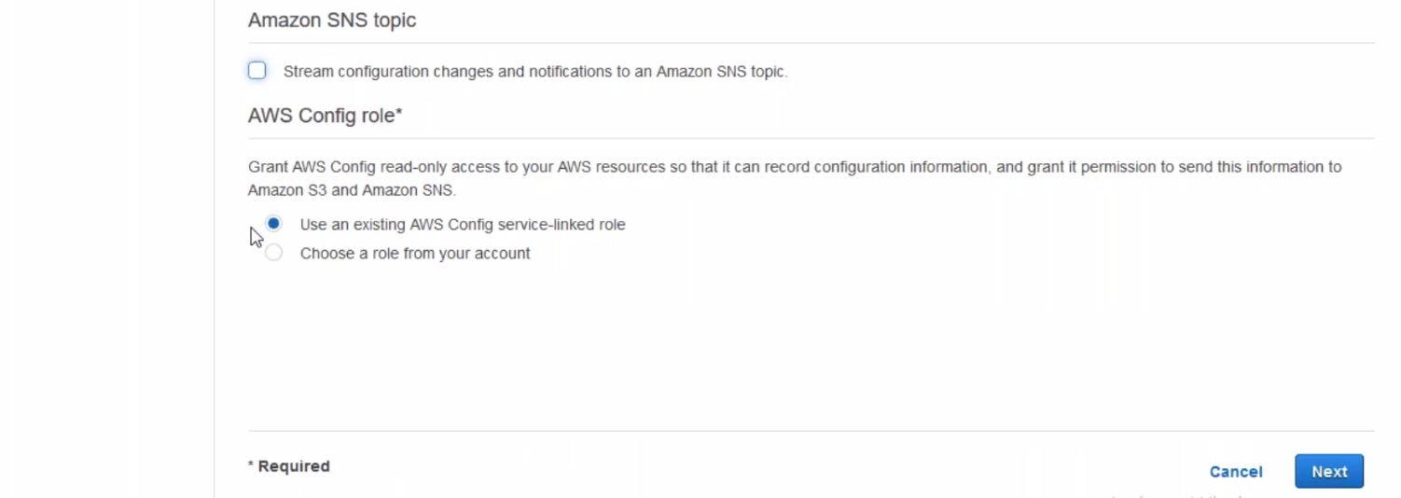

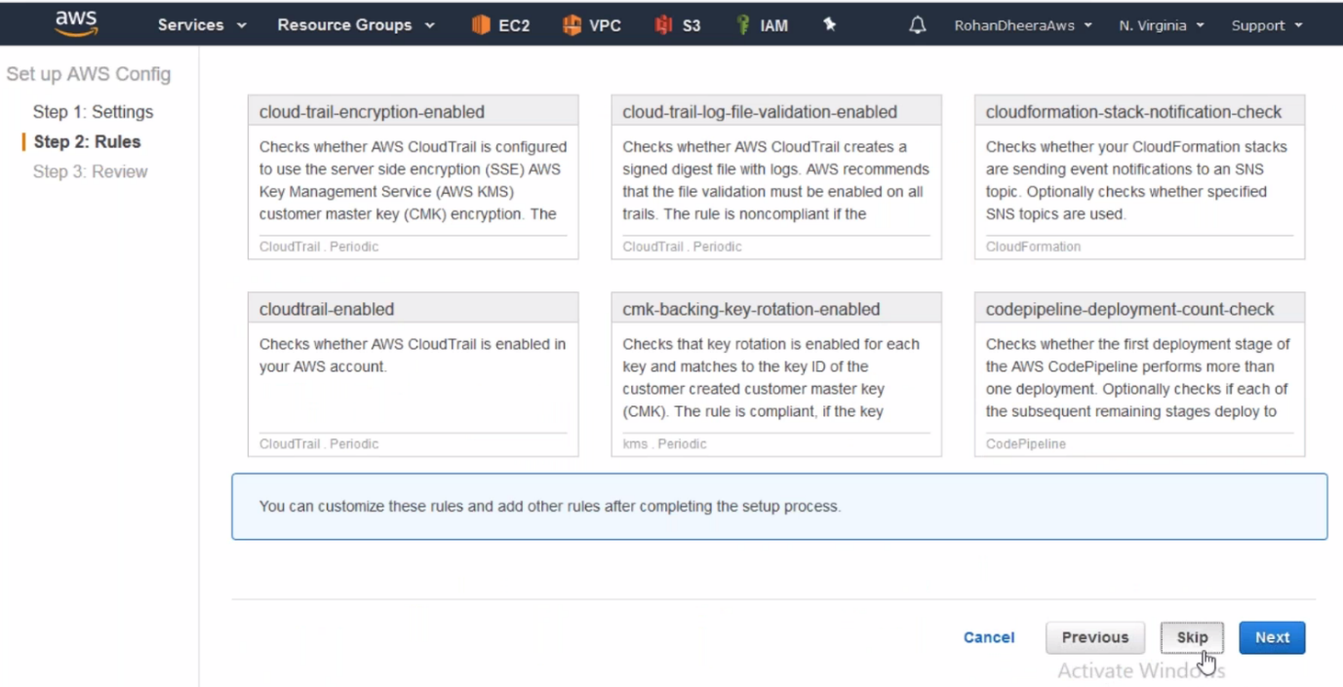

--- skip the rules

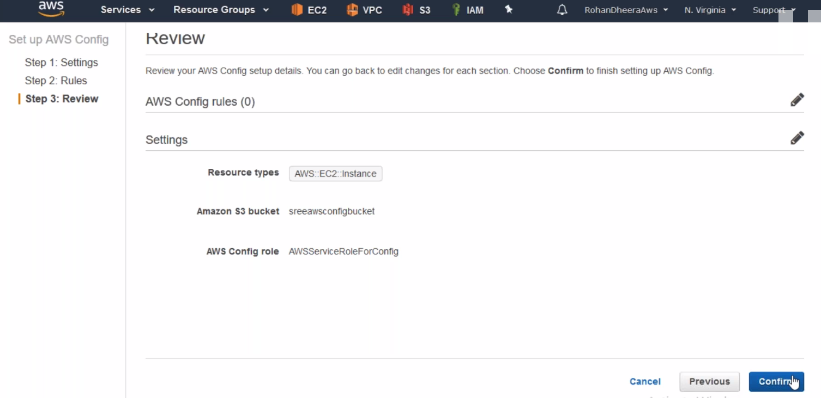

--- now the AWS config will start

**Check config’s saved or not**

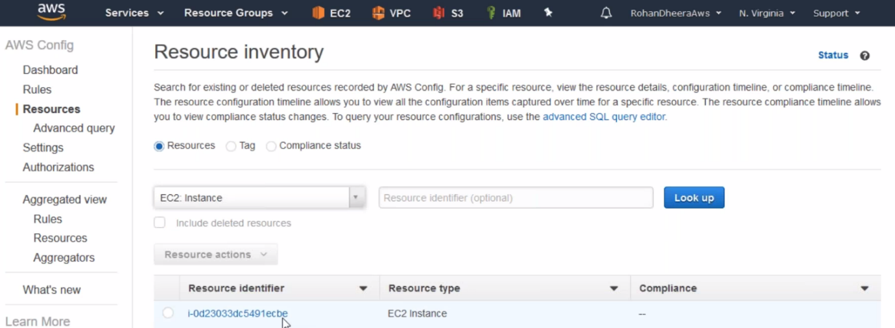

--- click on that EC2 instance

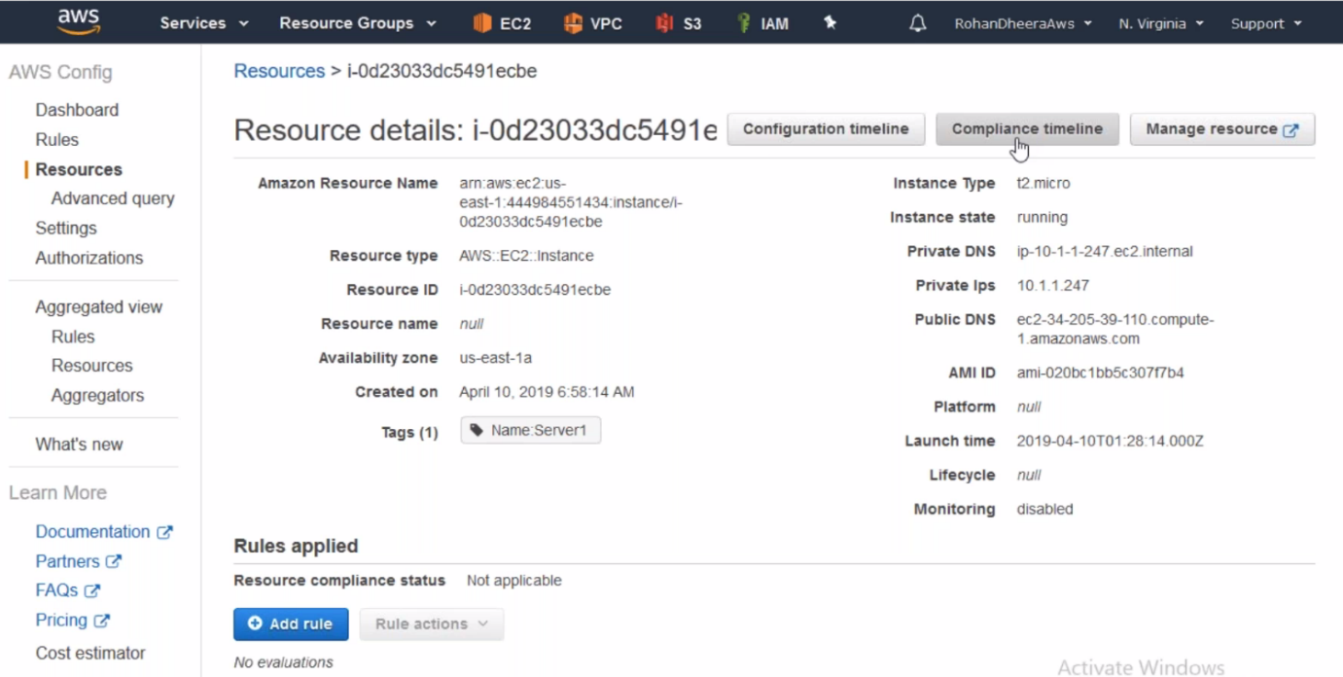

--- you can find 1.configuration time line 2.compliance timeline

1.**configuration timeline**

1.**configuration timeline** – period of time changes done by will be saved here. Like changing security groups, elastic IP address assigning…etc

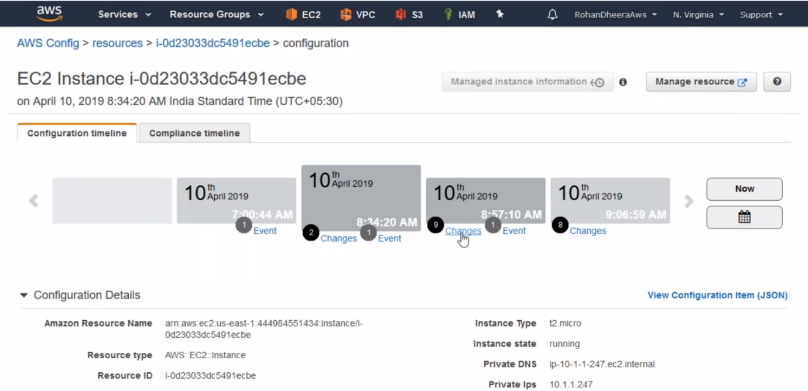

--- click on the configuration timeline. Here we have total of 9 changes, scroll down to see total changes

**2.compliance timeline**

2.**compliance timeline** – here we can assign rules, like we asked to assign elastic IP, want check IP is assigned or not.

**CloudTrail**

The cloud trail will give login details, timing…etc the details will be saved up to 90 days.

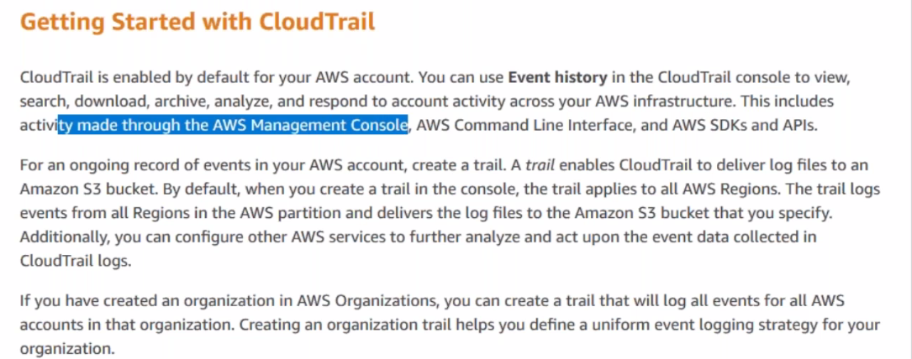

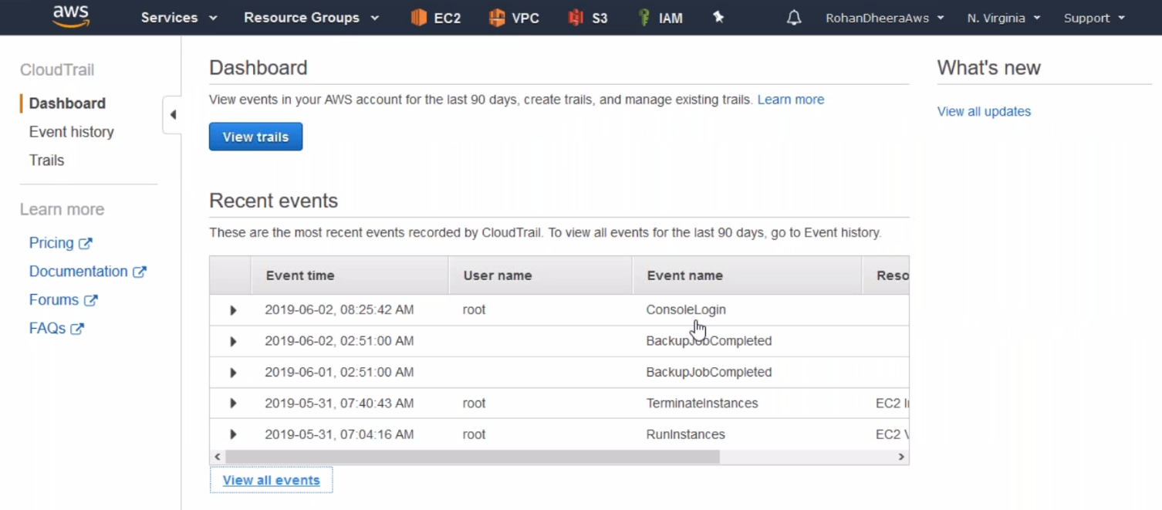

**Trials**

All the history is saved in trails like login details ..etc

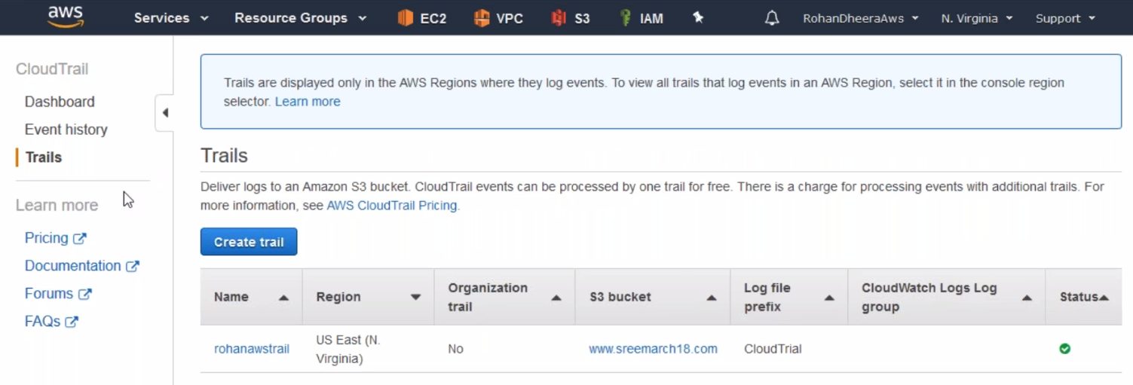

**Service Catalog**

you have a big environments and developers are not completely admins, developer wants to deploy EC2 machines so you can give permission to developers using this Service Catalog.

This service Catalog is not important unless your maintaining a big environments.

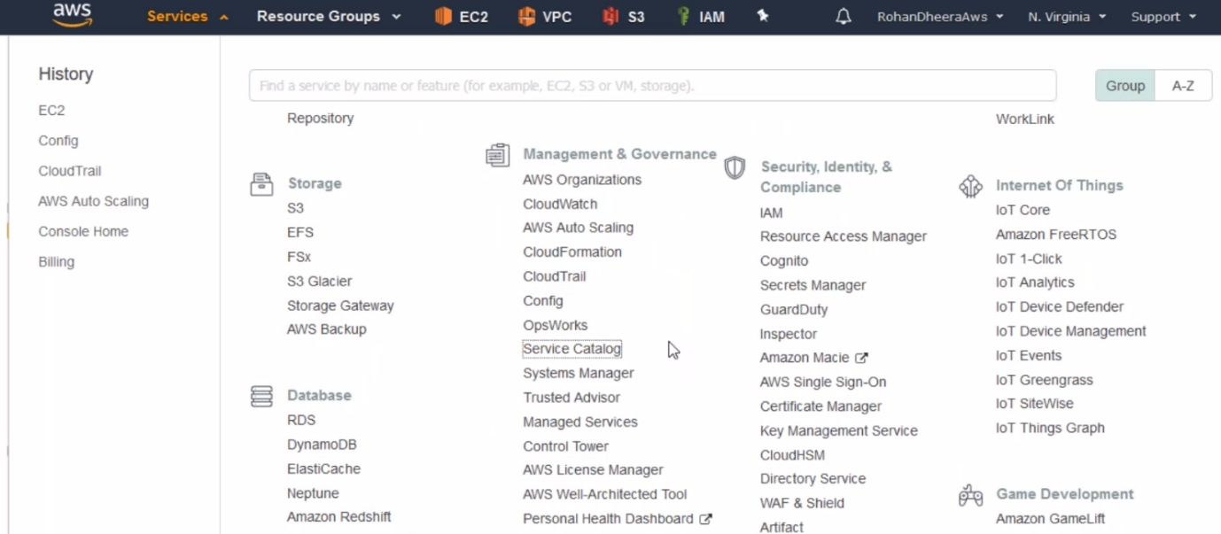

**Portfolios creating**

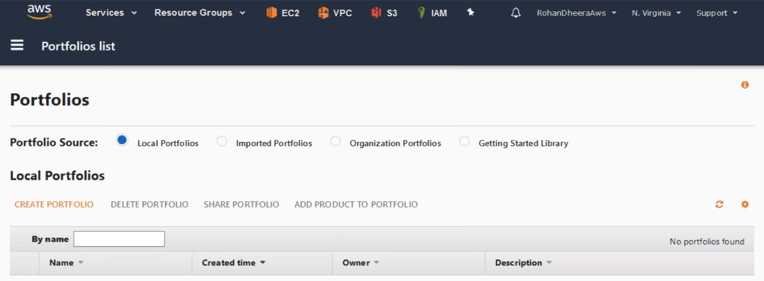

--- click on CREATE PORTFOLIO.

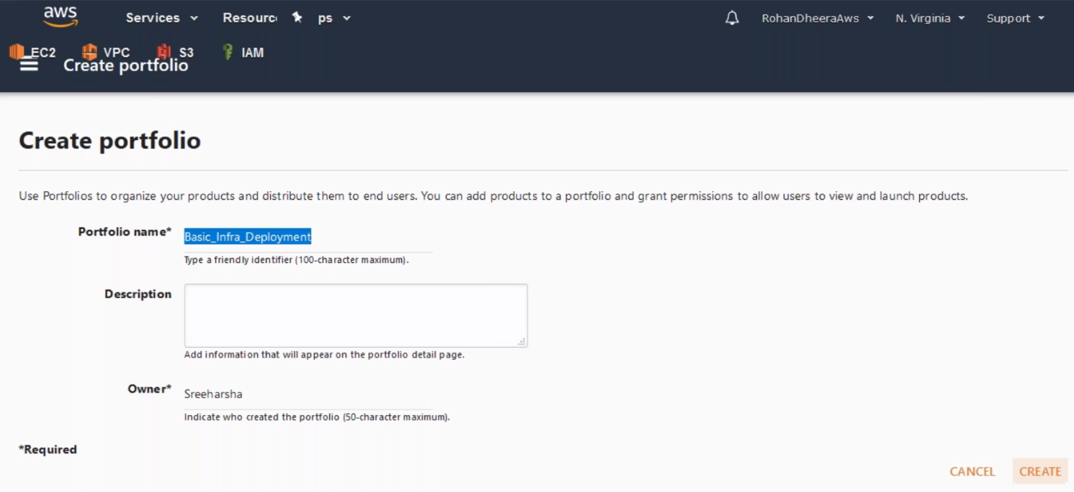

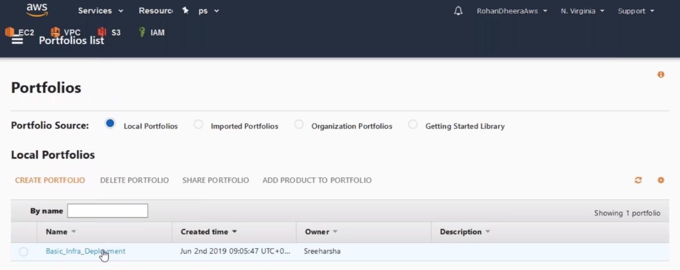

--- click on the portfolio you just created.

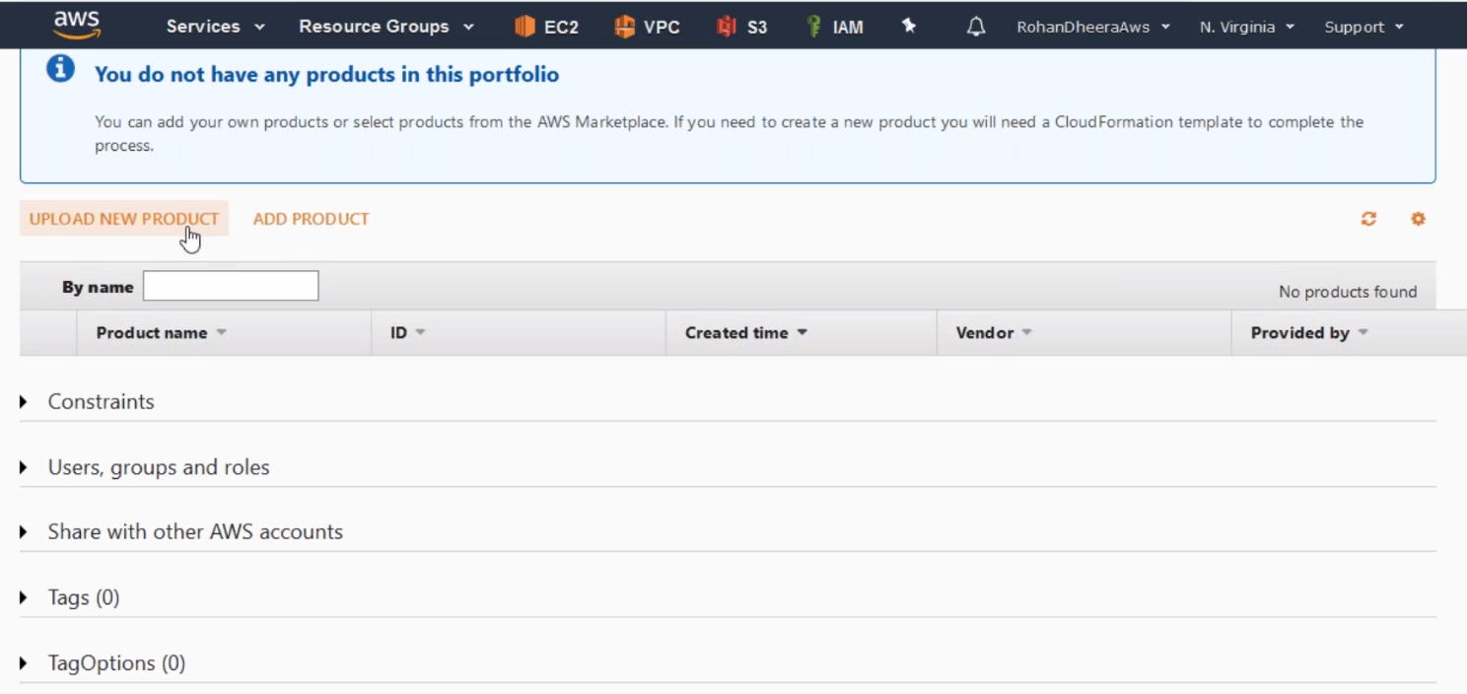

--- Click on Upload new product.

**Upload new product**

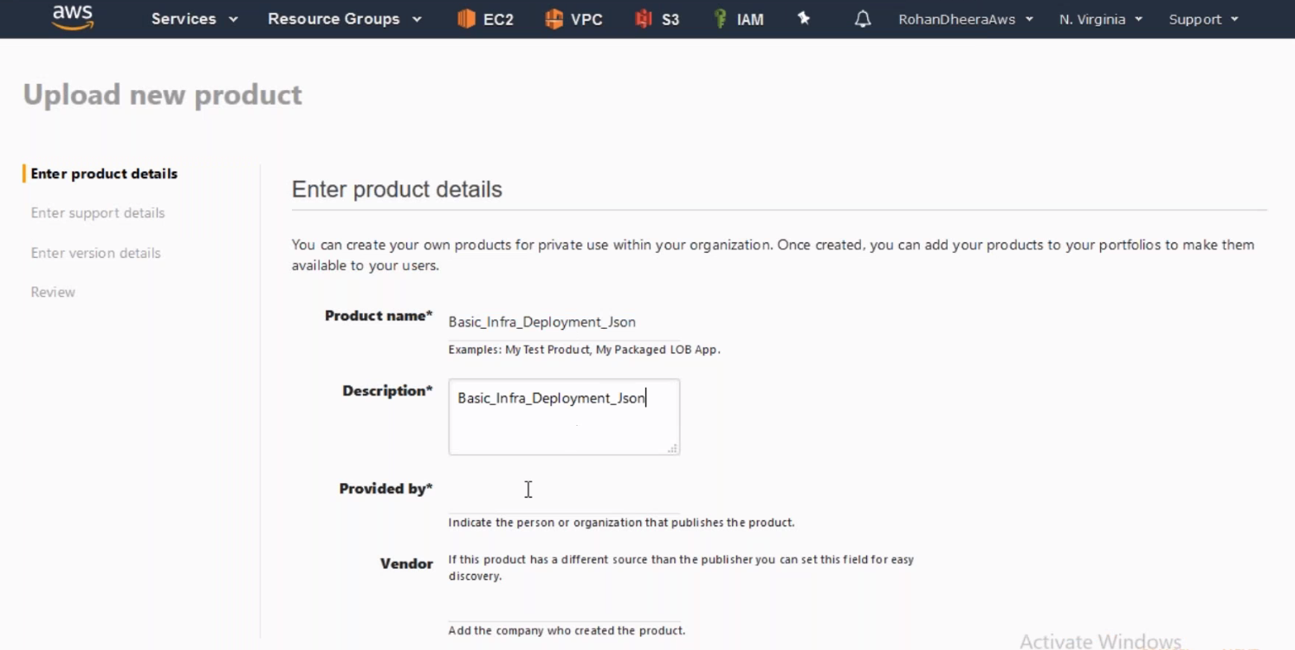

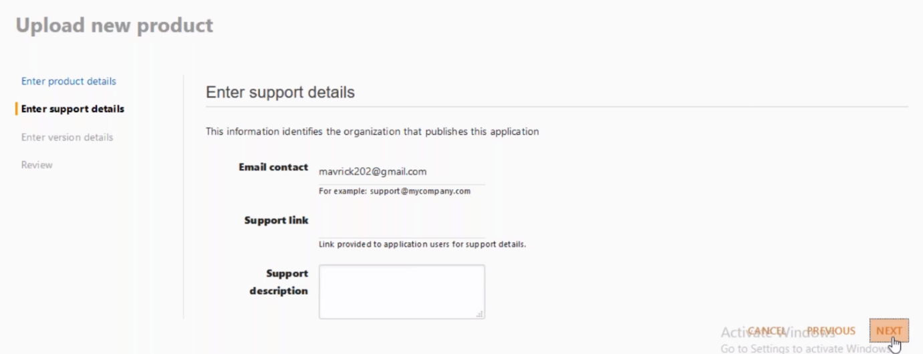

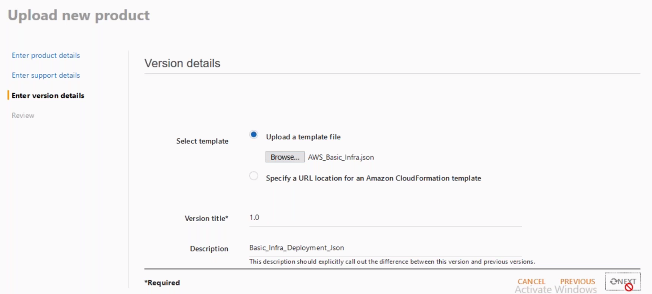

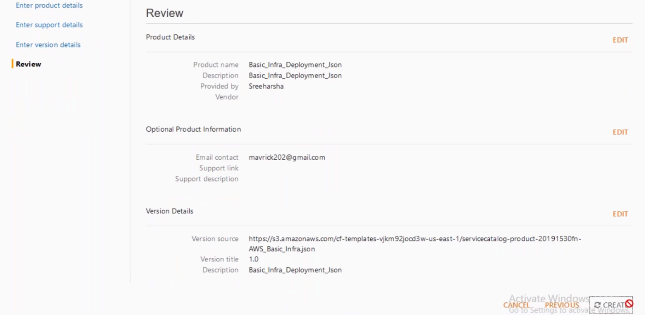

**Add Product**

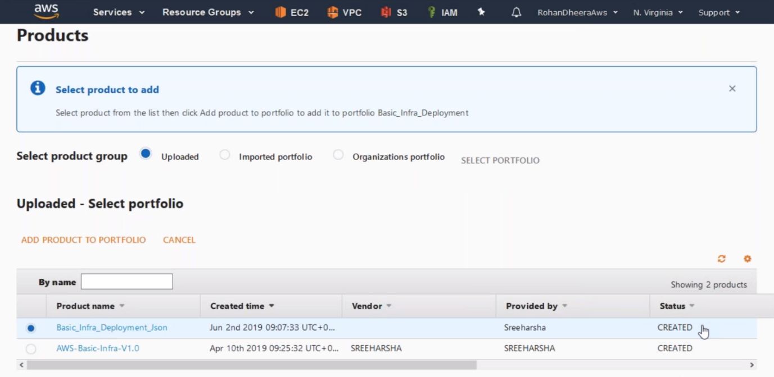

--- click on Add Product to portfolio

**Giving user permission**

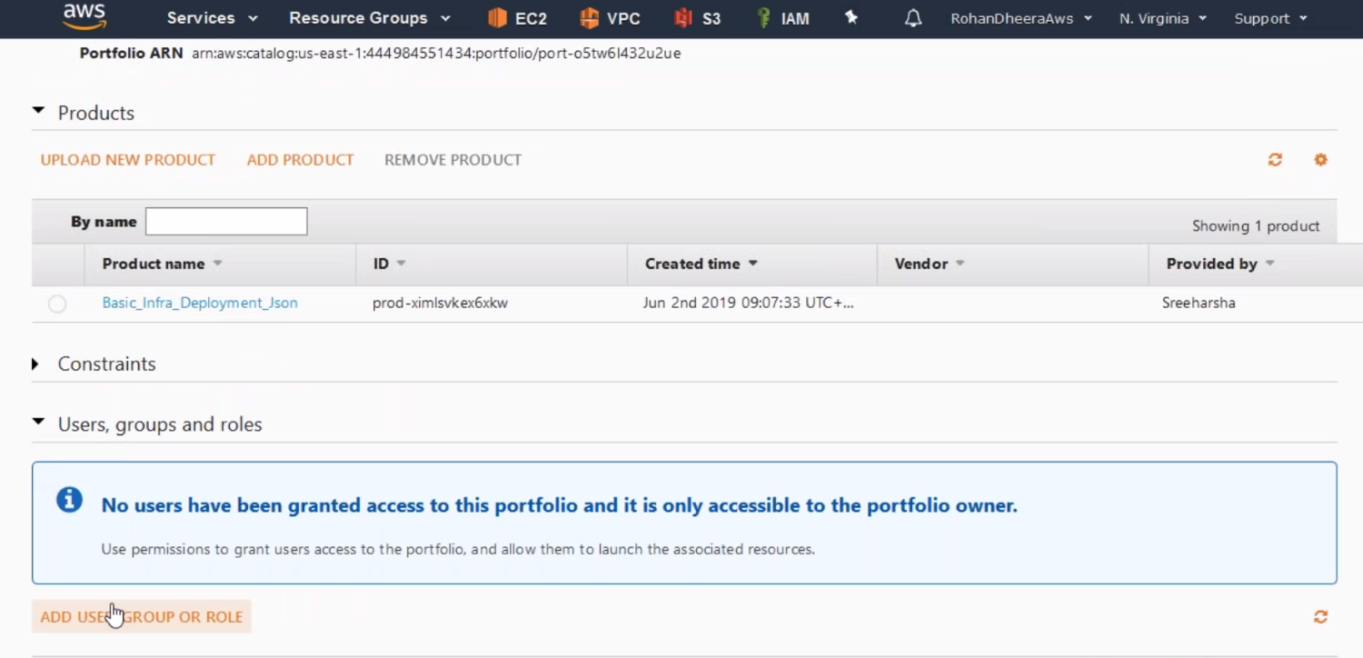

--- click on ADD USER GROUP OR ROLE

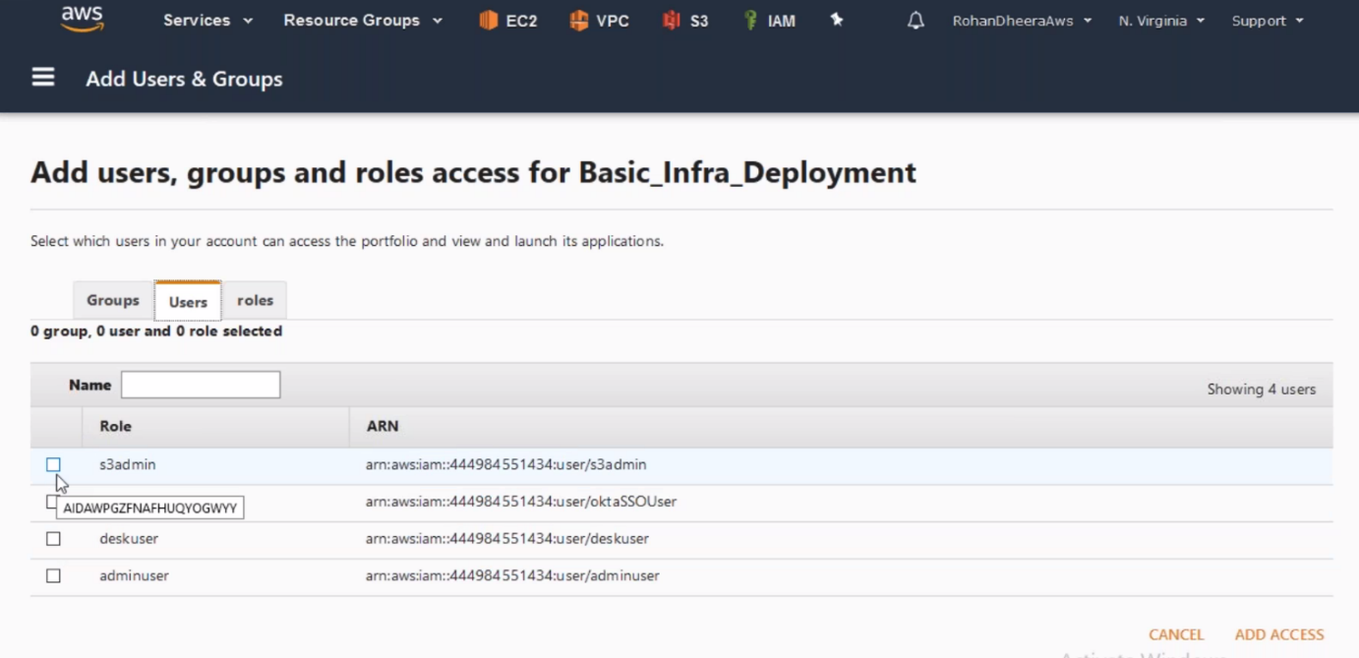

**System Manager**

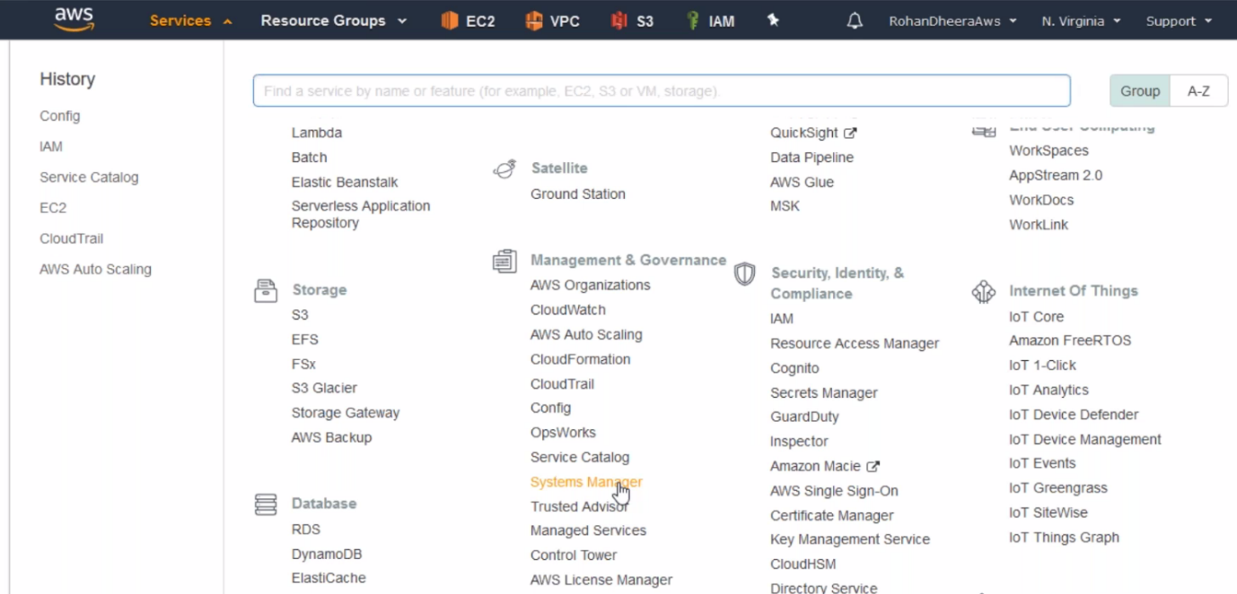

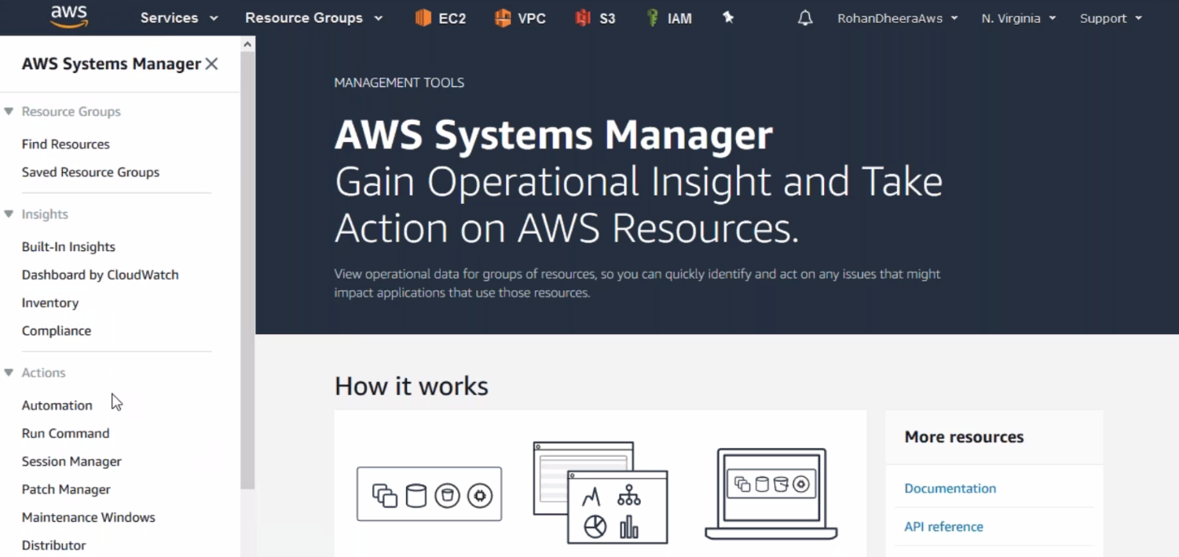

--- same like EC2 system manager only difference here is session manager.

**Trusted Advisor**

You want overall account snapshot

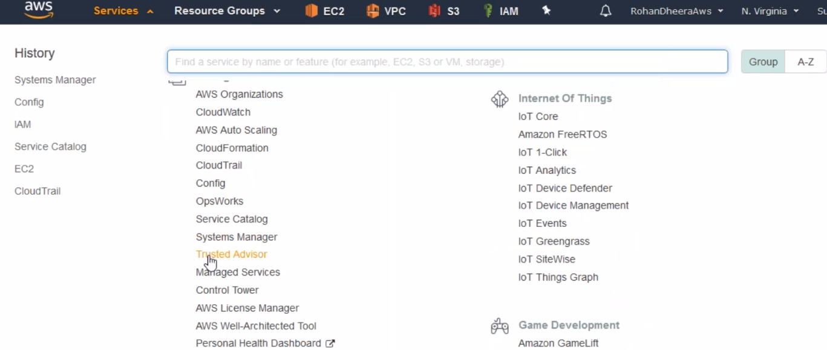

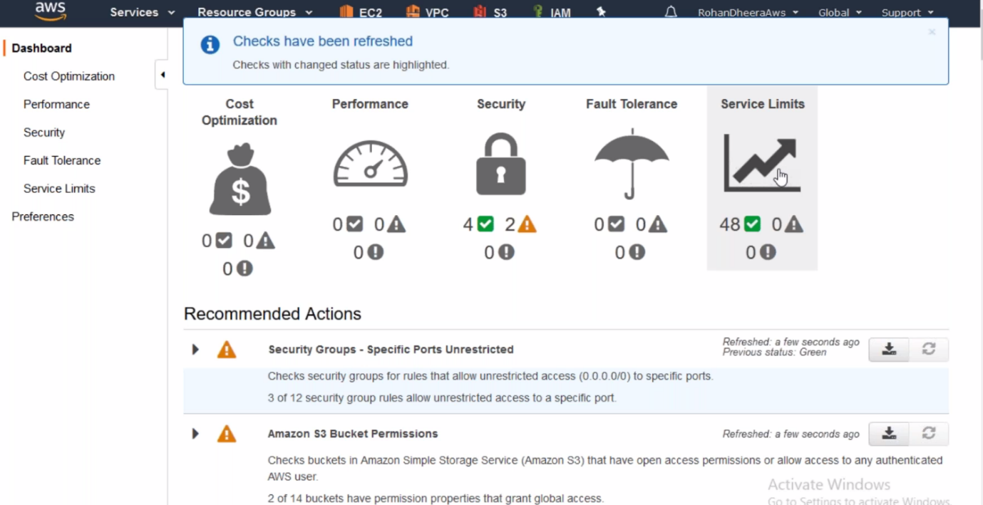

--- service limits – only 5VPC’S have to be created if this limit over come by some one then you will get alert. Any expiring then you will get alert.

**AWS LICENSE MANAGER**

You have a enterprise level environment and have heavy licence’s. you can manage those licenses using this AWS license manager

